Contents
Height Adjustment 2
Lumbar Support 2
Armrest 3
Seat Pan 3
Purchase information for recommended chairs 3
Criterion Chair by Steelcase 3
Embody Chair by Herman Miller 4
Focus Chair by SitOnIt 4
Leap Chair by Steelcase 4
Zody Chair by Haworth 5
Bodybilt by ErgoGenesis 5

There are several recommended chairs in our Penn Online Ergonomic assessment tool. These are just options with the features that we recommend. You can find another chair that works for your workstation if it has the following features:
- Pneumatic height adjustment
- Seat back adjustment (lumbar support, tilt)
- Armrest adjustment
- Seat depth adjustment

Ergonomic chairs are designed to be adjustable so that you can maintain a neutral posture while working. An adjustable chair allows you to position yourself with the least amount of body stress. Feet should be resting on the floor, legs bent about 90° and knees not touching the edge of chair, arms close to your sides, elbows bent about 90°, wrists straight, hands at keyboard height, head level and facing monitor, and back against the chair. This is neutral posture.
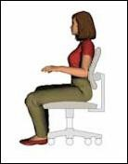
There isn’t one chair that fits everyone. A chair may have arm rests that are too wide for a petite person, or it may not adjust high enough for a tall person. Chair arms may hit the desk if you work in a corner but are fine if you work on a desk return. Review these chair features when looking for a chair for your specific workstation.

Height Adjustment
Check that the chair will adjust so that your feet can rest on the floor or a footrest. Ideally, your feet should be on the floor, but if the desk is too high you may need to adjust the chair height to get the correct upper body position and use a footrest to support your lower body. If you raise your chair and do not use a footrest your thighs will have additional pressure from the edge of the chair, or you will rest your feet on the base of the chair reducing circulation. There are chairs for petite and big and tall individuals that provide more range of adjustment if needed.

Lumbar Support
Poor back support can lead to pain and fatigue. A chair should have some lumbar support. The back of the chair should fit the curve of the spine. Chairs should allow you to adjust the height

of the lumbar support to fit the lower back comfortably. You sit all the way back in the chair to use the support. Do not perch on the edge of the chair leaning forward.

Armrest
Use of an arm rest is optional. If an armrest hits the edge of the desk and does not allow you to get close enough to your desk you can remove the armrest. An armrest can put you into awkward postures if not adjusted correctly. If the armrest is too low, you may lean to the side to reach the rest. If armrests are too high, you may raise your shoulders and cause neck and shoulder fatigue. If the rests are too wide you may stretch to use them. The armrest should be set at the natural height of your elbow when you relax your shoulders and bend your elbows about 90°.

Seat Pan
The seat pan should be wide enough to support your thighs and have a rounded edge. Seat pans that are too short will put pressure on the lower body and cause individuals to lean forward. Seat pans that are too deep will put pressure on the knees and reduce circulation. People tend to perch on the edge of the seat if the seat pan is too long. Seat pans should be adjusted so that there is about 2-3 finger widths between the seat edge and your knee.

Purchase information for recommended chairs
Penn has chair vendors in the purchasing system. You can review chair features online and ask a vendor if there is a model available that you can try out before purchasing.

Embody Chair by Herman Miller (Embody Chair - Herman Miller Store)

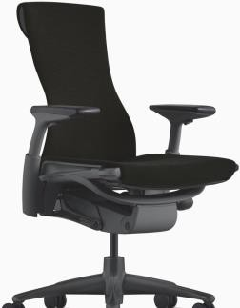
Vendor: CFI
Contact: Alfredo Sanchez
Email: alfredo.sanchez@cfiworkspace.com
Phone: 347.922.3974
Features: Fully adjustable arms, seat depth adjustment

Model # CN122AWAA

Price: (call for quotation)

Focus Chair by SitOnIt (Focus | Office Task Chairs | SitOnIt Seating)

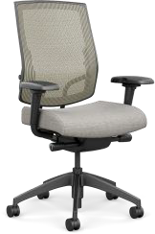
Vendor: CFI

Contact: Alfredo Sanchez
Email:alfredo.sanchez@cfiworkspace.com
Phone: 347.922.3974

Features: Enhanced Synchro Control, Multi-Adjustable Arms, Seat Depth Adjustment and Adjustable Lumbar Support.

Model # 5623YB1.A95

Price: (call for quotation)
Leap Chair by Steelcase (Leap Office Chair & Workspace Seating | Steelcase)
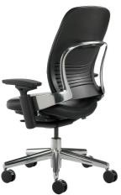
Vendor: Corporate Interiors

Contact: Sean Lee Phone: 610-994-1307

Features: Pneumatic height adjustment; lower back firmness; back stop; adjustable lumbar height; height, width, pivot adjustable arms; seat depth adjustment

Model #: LEAPV2

Zody Chair by Haworth (See Haworth's Zody Desk Chair | Haworth)
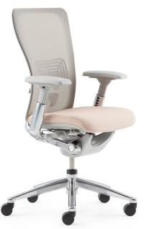
Vendor: Transamerican Office Furniture
Contact: Nicole Perna
Email nperna@transamfurn.com
Phone: (215) 482.8550 x223
Features: Pneumatic height adjustment; adjustable lumbar height; height, width, pivot adjustable arms; adjustable seat depth & back stop.

Model #: SZT-20-724MA5

Price: (Call for quotation.)

Bodybilt by ErgoGenesis (Midcelli - Mesh Back Chair - BodyBilt)

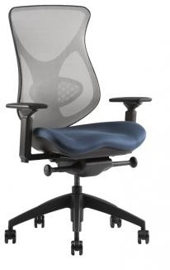
Vendor: ErgoGenesis

Contact: Howard Flowers
Phone: 202-255-1513
Features: Pneumatic height adjustment; adjustable lumbar height; height, width, pivot adjustable arms; adjustable seat depth & back stop.

Model #: Tall and Big & Tall

Price: (Call for quotation.)

