Hazard Control Plan
Pyrophoric Liquids and Solids: _______ Lab

TEMPLATE INSTRUCTIONS: Some sections will require more or less detail depending on your procedure. Send completed HCPs to ehrslaba@ehrs.upenn.edu for upload to your lab’s document section in BioRAFT. EHRS will review HCPs on your request; however, the supervising faculty member is responsible for ensuring that a thorough hazard assessment has been performed. Replace red text with your text in this template. Delete this message when submitting your HCP.

Purpose
• • •
A Hazard Control Plan (HCP) is a standard operating procedure for a specific process performed in your laboratory or department. The HCP describes the hazardous materials or equipment in use and details the controls that will be put in place to minimize risk of exposure, injury, and other incidents. While the HCP may also include experimental procedures, its purpose is primarily to document the hazards and controls for the process. An HCP is typically written for procedures with particularly high hazards or when new hazards are introduced for the first time. A hazard assessment must be repeated, and the HCP amended whenever changes are made to the process.

Hazard Control Plan
Pyrophoric Liquids and Solids: _______ Lab
Date HCP Prepared: [Date]
HCP Prepared by:
Name | [Name]
Position/title | [Position/title]
Email address | [Email]
Phone number | [Phone number]
Supervising Faculty Member | [Faculty member’s name]
Department | [Department name]
Contributors | [Names]

Location of Process:
Building | [Building]
Room number | [Room]
EHRS hood number (if applicable) | [3-4 digit EHRS ID Hood Numbers]
Other location information | [Other location info, including storage, if applicable]

References:
[Insert literature or research notebook references for this procedure here. Specify which procedure in the paper is the one you will be following, e.g. “Method 3, page 1427”]
[Specify here if there are any parts of the procedure you will be modifying in your experiment, e.g. using a different solvent, a different substitution on a molecule, or different reaction conditions such as temp]
[Insert references/links to equipment manuals for any equipment you will be using in the procedure. We recommend uploading equipment manuals to your lab’s Documents section in BioRAFT and linking to that page for easy reference and access by lab members and EHRS.]

Rathman, T. and Schwindeman J. A. Preparation, Properties, and Safe Handling of Commercial Organolithiums: Alkyllithiums, Lithium sec-Organoamides, and Lithium Alkoxides. Org. Process Res. Dev. 2014, 18 (10), 1192–1210. DOI: 10.1021/op500161b

General Description
Pyrophoric reagents are reactive compounds that react vigorously with water, protic solvents, and in some cases oxygen; this either directly results in a fire, or evolves enough heat and flammable gas to strongly risk one. Because of this, they must be handled under an inert atmosphere and in such a way that rigorously excludes air/moisture. Solvents used for these reactions are generally ethereal or hydrocarbon solvents and must be kept dry. Reaction vessels must be dried in an oven for # hours or flame dried and thoroughly purged with inert gas (argon or nitrogen) before use. Cold baths may be used to mitigate the strongly exothermic reactions.
Some are toxic, and many come dissolved or immersed in a flammable solvent. Other common hazards include corrosivity, teratogenicity, or peroxide formation, and pyrophoric reagents may cause damage to the liver, kidneys, and central nervous system The reagent must be withdrawn from the reagent bottle using an inert gas line and a luer lock syringe or cannula. Addition of the reagent must be done very gradually.

Scope and Limitations
This Hazard Control Plan applies to the equipment, chemicals, and tasks described herein. Any deviation in materials, pressures, temperatures, or other operational parameters specified in this HCP must be evaluated for new potential hazards and necessary controls before implementation of the changes.
Reactions using pyrophoric reagents are run with a variety of reagents and organic solvents. Each of these has their own health and safety risks. The SDS for all reaction components must be consulted prior to setting up the reaction using pyrophoric reagents.

Hazard Identification
The following chemical and physical hazards have been identified for this process/equipment. [put “x” in box next to hazards]
 | Chemical |  | Physical/Other
 | Carcinogens |  | Ionizing radiation
 | Corrosive Liquids |  | Radioactive materials
 | Perchloric Acid |  | Lasers
 | Engineered Nano Materials |  | UV light sources
 | Flammable Chemicals | x | Inert compressed gases
 | Hazardous Gas (Flammable, Oxidizing, Corrosive, Toxic) |  | Electrical Hazards
 | Highly Toxic Chemicals |  | Heavy material handling equipment
 | Irritants |  | Working at Heights (4 foot or higher)
 | Explosive compounds |  | High heat
 | Peroxide formers |  | Open Flame
x | Pyrophoric chemicals |  | Lithium Batteries
 | Strong Oxidizers |  | Noise hazards
x | Water Reactive Chemicals |  | Particulates from machines and operations
 | Cryogens and Dry Ice |  | Pressure and Vacuum vessels
 | Teratogens and/or reproductive hazards |  | Robotic Machinery
 | Exothermic reaction/Other chemical reactivity hazards |  | Shop equipment
 |  |  | Biological Hazards
 |  | x | Exposed blades, needles, etc.
 |  |  | Acute/Chronic Aquatic Hazard

Training Requirements
Training beyond the standard EHRS lab safety training is required for hazardous lab processes. Hands-on training by a senior lab member experienced in the use of pyrophoric reagents is required before new lab members can perform experiments with pyrophoric reagents. All researchers conducting this experiment must read and understand the applicable SOPs and Fact Sheets in Penn’s Chemical Hygiene Plan.
After completing the training, the new lab member must obtain approval from the PI prior to commencing work. No researcher may work independently with the hazardous material described in this HCP until the Principal Investigator (or their designee) has ensured that the researcher:
- Has completed all required EHRS laboratory safety training programs.
- Understands the hazards of the materials and risks of the processes involved.
- Has read and understands the contents of the related SOP(s) and/or Fact Sheets on the hazard (available on EHRS’s website) and this task-specific Hazard Control Plan.
- Demonstrates the ability to execute their work according to the requirements in the related SOP(s) and/or Fact Sheets on the hazard (available on EHRS’s website) and this task-specific Hazard Control Plan.

Tasks, Hazards, and Controls
Describe each process step that involves a hazardous material or procedure. Replace the use of “should be/do” statements with “must be/do” statements as much as possible; this reduces the risk of someone misinterpreting “should” statements as optional instructions.
(See Appendix B for an example task description)

Hazard-Control Table Instructions: (Delete these instructions before submitting your draft)
(See Appendix B at the end of this document for an example of a completed table)
- Fill in the Hazard (e.g. Flammable Chemical, or Toxic Gas, etc.) in the top row.
- Enter the Risk (e.g. Fire, or Illness/Death due to inhalation).
- Enter the Risk Factors (e.g. For Fire: Strong oxidizers, open flames; For Illness/Death from inhalation: Leaks in tubing, inadequate post-reaction purge time).
- Define the likelihood and severity of the Risk.
  - See Appendix A at the end of this document for definitions of Risk likelihood and severity levels (High(H), Medium(M), and Low(L)).
- Fill-in any hazard controls that are in place or will be put in place. (You do not need to enter a control for each category.)
  - See Appendix B at the end of this document for an example of a completed Hazard Control Table.
- It is most efficient to group materials that have similar hazard controls in place, and/or quenching procedures. This way, the fewest number of tables must be written. (e.g. most flammable gases have the same controls, so it is best to create a “Flammable Gas” table).
- If a material has multiple hazards (e.g. Carbon Monoxide is toxic and flammable) and you have other materials that fit one or both hazards, writing tables for both hazards (e.g. “Toxic Gases” and “Flammable Gases”) is sufficient.
- If a material has multiple hazards (e.g. Carbon Monoxide is toxic and flammable) but no other materials fit one of the hazard types (e.g. Carbon Monoxide is your only toxic gas, you have other flammable gases), you may specify extra controls for that material in one hazard table, rather than writing another table (e.g. include “Use a handheld CO detector to detect leaks when working with CO” in your “Flammable Gases” table).
Duplicate the table as many times as is necessary for each hazard and risk of each step.

- Setting up a dry ice or liquid nitrogen (LN₂) cooling bath
Reactions using organolithiums, Grignards, or strong amine bases are often run at reduced temperatures using dry ice or LN₂ to counteract significant exothermal activity. A common cooling bath is acetone and dry ice to maintain -78 °C reaction conditions. This must be set up in an approved Dewar-flask. The bath must first be filled with acetone and then dry ice; be mindful to not overfill as when you add the dry ice it will increase in volume and can overflow. Carefully add dry ice while wearing the appropriate cryogenic protection and using a plastic scoop. Add dry ice one piece at a time; adding dry ice too quickly may cause the acetone to bubble over. Eventually, after adding a piece of dry ice the bubbling will decrease greatly and the rate of adding dry ice can be increased. The reaction vessel can then be slowly lowered into the cooling bath. Exercise caution as adding the room temperature flask will cause bubbling to occur and the liquid may overflow.

LN₂ baths can be prepared in a similar fashion. While wearing cryogen gloves and a face shield, dispense LN₂ from the bulk tank using a phase separator into an intermediate atmospheric Dewar storage container. From the intermediate storage container, pour the LN₂ into the Dewar flask slowly to prevent excessive bubbling. The reaction vessel must then be lowered into the LN₂ very slowly to prevent LN₂ from boiling violently and spilling. In both cases, the cooling liquid must have a space of ~3-5 centimeters between the liquid level and top of the Dewar to prevent boiling over.
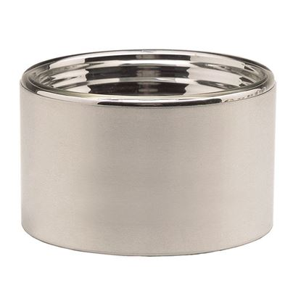
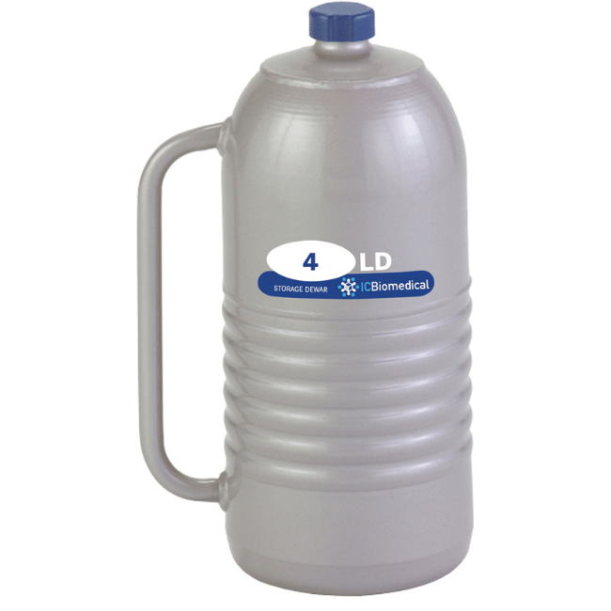
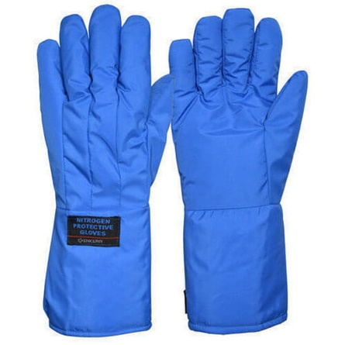

From left to right, examples of a Dewar Flask, an atmospheric Dewar storage container, and cryogenic gloves.
Hazard: Cryogens
Risk | Likelihood | Severity | Risk Factors
Cold burns | L | L | -Not wearing sufficient PPE  -Rapid addition of dry ice, or adding warm coolant (e.g. acetone) causing the bath to overflow  [Enter any additional risk factors here – conditions or actions that would increase risk]
Controls
Administrative [work practices] | –Be patient when adding dry ice to avoid overflowing.  –Create cold bath in the order of: acetone first, then dry ice, then the reaction flask.  –Create cold bath as close as possible to location of intended use to minimize the risk of spills during transport.  [Indicate any additional work practices taken to increase safety during this process.]
Engineering | –Use a plastic scoop for dry ice transfer  –Use a Dewar flask to contain the cooling bath  [Indicate any additional engineering controls in place to increase safety during this process.]
Personal Protective Equipment | When filling Dewar flasks with dry ice, wear the following PPE:  - Safety glasses  - 100% cotton or flame-resistant lab coat  - Solvent-appropriate gloves  - Cryogenic gloves  When pouring liquid nitrogen, wear a face shield in addition to the above PPE.  [Indicate any additional PPE used to increase safety during this process.]
Other mitigating factors
(inherent risk reduction)
Link to Penn Chemical Hygiene Plan SOP for this hazard: https://ehrs.upenn.edu/health-safety/lab-safety/chemical-hygiene-plan/standard-operating-procedures/sop-cryogens-and-dry

- Steps for syringe transfer of a pyrophoric reagent:
  - Prepare flasks of hexanes, isopropanol, and methanol in the fume hood to quench your syringe with after pyrophoric reagent transfer.
  - Dry your reaction vessel by…
  - Clamp the reagent bottle and reaction vessel in place to prevent spillage from tipping.
  - Prepare your dried reaction vessel by purging it with vacuum/inert gas cycles (see table below for details), connecting it to an inert gas line equipped with a bubbler, and placing a soft stopper on one of its openings.
    - Add non-pyrophoric reagents and dried solvents as necessary and appropriate.
  - To maintain atmospheric pressure in the reagent bottle while measuring reagent, an inert gas supply connected to a bubbler must be inserted into the bottle, through the sure seal.
  - A leak-tested luer-lock syringe with a needle of sufficient length to safely reach the reagent and be able to bend the syringe barrel to be vertical must be used.
    - Syringes can be leak-tested by partially piercing a cork stand and attempting to depress the plunger to about half-volume. Significant resistance will be felt; otherwise, the syringe has a leak and new one must be selected.
  - First the needle must be inserted, and inert gas taken into the syringe. After removing the needle from the sure seal, the inert gas must be expelled. These purges are repeated a total of 3x to remove air from the syringe and needle.
  - Afterwards, submerge the needle into the reagent layer and draw up the desired volume of pyrophoric reagent. Never fill the syringe barrel to more than two-thirds capacity.
    - Use a larger syringe barrel or a cannula if more reagent is needed.
    - Do not reuse syringes or use multiple syringes for one reaction.
  - Bring the needle above the surface of the reagent, then tip the syringe barrel upside down. Slowly force bubbles and excess reagent back into the reagent flask. Continue until the exact volume is indicated.
  - Now that the exact volume is indicated, draw the plunger back a short amount to create a headspace of inert gas in the syringe.
  - Hold the syringe barrel and plunger with one hand and carefully extract the needle through the septum with the other. Quickly insert the needle into the (dry) receiver flask, avoiding prolonged exposure to the atmosphere.
  - Press the needle through the stopper in the reaction flask while keeping the syringe chamber pointing upwards. Slowly expel the buffer inert gas into the reaction vessel and then orient the syringe chamber downwards. The reagent can then be added slowly.
  - After the reagent has been entirely dispensed into the prepared reagent flask, pull an inert gas buffer from the reaction flask. Remove the needle with the syringe chamber pointing upwards.
  - Immediately quench the residual pyrophoric reagent in the syringe by first expelling the buffer gas into the prepared vessel containing hexanes. Then, take up hexanes to fill the syringe entirely. Flush the syringe with hexanes 3x in the same vessel. Slowly add isopropanol to the flask of hexanes to react with excess reagent and flush the syringe another 3x. Add methanol to the flask of hexanes and isopropanol to further react and flush the syringe another 3x. Dispose of the needle/syringe in chemically contaminated sharps container.
  - [If the reaction needs to be quenched before/during work-up, include instructions here.]
  - Dispose of quenching solution as hazardous chemical waste and dispose of syringe in an appropriately-labeled sharps container (see Waste Disposal section below).
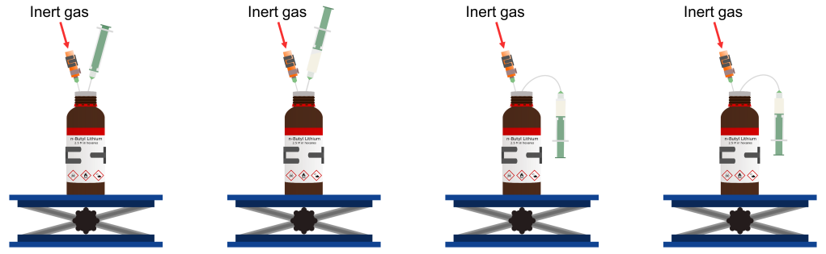
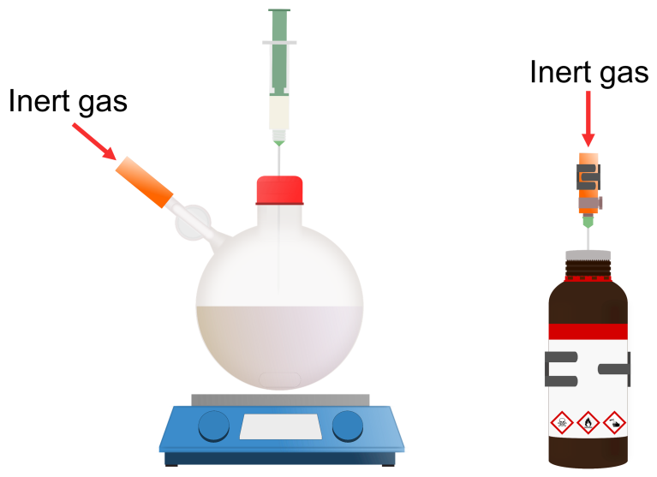
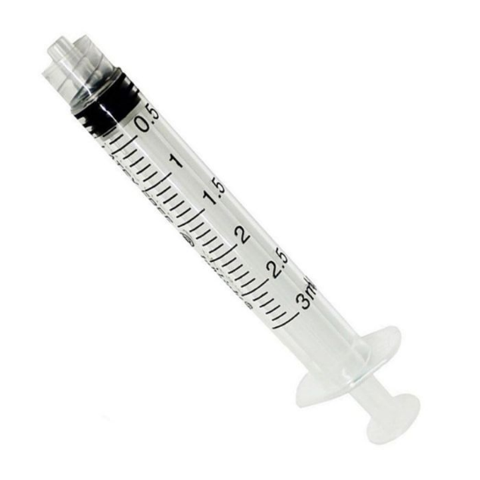

Luer-lock syringe

- Steps for cannula transfer of a pyrophoric reagent:
- Prepare flasks of hexanes, isopropanol, and methanol in the fume hood to quench your syringe with after pyrophoric reagent transfer. Equip each flask with a soft stopper and clamp in place.
- Dry your reaction vessel and cannula by… The cannula must be allowed to cool to room temperature in a desiccator while awaiting use.
- Clamp the reagent bottle and reaction vessel in place to prevent spillage from tipping.
- Prepare your dried reaction vessel (receiving flask) by purging it with vacuum/inert gas cycles (see table below for details), connecting it to an inert gas line equipped with a bubbler, and placing a soft stopper on one of its openings.
    - Add non-pyrophoric reagents and dried solvents as necessary and appropriate.
- To maintain atmospheric pressure in the reagent bottle while measuring reagent, an inert gas supply connected to a bubbler must be inserted into the bottle, through the sure seal. The pressure gradient must flow from the reagent bottle to the receiving flask. Establish this by…
- Insert one end of the cannula through the septum of the receiving flask. Insert the other end into the reagent bottle. Once this end of the cannula is submerged, reagent transfer will begin. Keep the cannula submerged until all of the reagent is transferred.
  - If liquid will not flow at an appreciable rate during cannula transfer, consider changing to a wider gauge cannula and/or carefully and securely elevating the delivery vessel above the level of the receiving flask.
- When all of the liquid has been transferred, first remove the connection to the inert gas line from the receiving flask and then remove the cannula at the reagent flask end.
- The remaining apparatus may be disassembled in any order, but exercise extreme caution as there will likely be pyrophoric residue remaining.
- Immediately quench the residual pyrophoric liquid in the cannula by placing one end through the soft stopper of the flask containing hexanes and the other end through the soft stopper of the flask containing isopropanol. Discharge the hexanes through the cannula into the isopropanol by applying positive gas pressure to the hexanes flask and venting the isopropanol flask. Repeat this step by discharging this solution through the cannula into methanol.
- Dispose of quenching solution as hazardous chemical waste (see Waste Disposal section below).
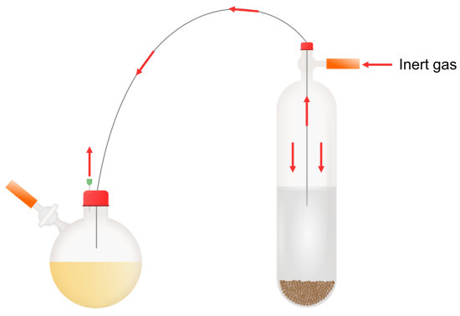

Hazard: Pyrophoric Liquid
Risk | Likelihood | Severity | Risk Factors
Fire caused by reagent exposure to moisture/air | M | M | –Reagent not fully being removed from the syringe when filling syringe with buffer layer of inert gas  –Buffer gas layer being too thin.  –Pyrophoric chemical container being knocked over.  –Solvent not being dry, or reaction flask not properly being purged with inert gas.  –Forgetting to quench excess reagents/residue.  During quenching:  –Neutralizing solvents may not be dry of water; water reacts too vigorously.  –Quenching solvents added too rapidly, resulting in runaway exothermic reaction.  –Use of flammable solvents in neutralization process.  [Enter any additional risk factors here – conditions or actions that would increase risk]
Controls
Administrative [work practices] | –Do not work alone with pyrophoric chemicals. Notify lab members when the reagent will be used.  –Clean excess solvents and flammable material from surrounding area before beginning work to mitigate the possibility of fire spreading and to allow for the easy handling of materials.  –Collect reagent in syringe as close as possible to location of intended use to minimize the risk of spills during transport.  –A glass dish of fire sand will be kept in the hood and a bucket of extra fire sand will be kept in [location] in case of a small fire.  –Test the syringe for leaks before use.  –Reaction vessels and cannulae must be dried in an oven (###°C) for at least (#) hours or flame dried and thoroughly purged with inert gas (argon or nitrogen) before use.  –Before the addition of pyrophoric reagents the reaction flask must be purged with inert gas with vacuum/argon cycles (3x, X minutes per cycle), or blowing argon through the reaction vessel and out of an outlet needle for: ~1-2 mins (<50mL flasks); ~5 mins (100-500 mL flasks); ~10 mins (>1000 mL flasks)  –Ensure that solvent is thoroughly dried and, if not from the solvent purification system (Room(s) XXXX), sparged with inert gas for 15 minutes before use.  –Close and store reagent bottle immediately after transferring desired amount.  –Quench the residual pyrophoric reagent inside of syringes and used glassware as soon as possible after use. Do not quench empty manufacturer’s reagent bottles (See Waste Disposal section at the end of this document).  –Thoroughly rinse all glassware with appropriate solution after use and clean thoroughly.  –Do not perform any other procedures in the fume hood until the reaction is complete, materials/waste have been disposed of, and the pyrophoric reagent has been removed from the area.  –Post a sign on the fume hood when a process involving potentially pyrophoric compounds is unoccupied. A template is available for download: Unattended Operations Sign Template  [Indicate any additional work practices taken to increase safety during this process.]
Engineering | –Clamp all vessels containing pyrophoric reagents in place.  –Perform all experiments in a fume hood to contain fumes, spills, and fires. Keep fume hood sash closed as much as feasible.  –Use a luer-lock syringe with an appropriately sized needle and properly-fitting plunger or a metal cannula for liquid transfer.  –Inert gas lines must be connected to a bubbler to prevent spills/sprays due to overpressurization.  [Indicate any additional engineering controls in place to increase safety during this process.]
Personal Protective Equipment | –Standard lab attire (long pants, fully-enclosed shoes, etc.)  –Safety glasses, 100% cotton lab coat, solvent-appropriate gloves (suitable below 1g or 10 mL of pyrophoric reagent)  –Safety glasses, fire-resistant lab coat, solvent-appropriate gloves (suitable at any scale of pyrophoric reagent)  [Indicate any additional PPE used to increase safety during this process.]
Other mitigating factors
(inherent risk reduction)
Link to Penn Chemical Hygiene Plan SOP for this hazard: https://ehrs.upenn.edu/health-safety/lab-safety/chemical-hygiene-plan/standard-operating-procedures/sop-pyrophoric

- Solid Pyrophorics (e.g. Lithium Aluminum Hydride)
Weighing pyrophoric solids must be done in a timely manner to avoid excess exposure to moisture in the air. The pyrophoric reagent must be added to a pre-dried flask and purged with inert gas (see options in table below) before any reagents or solvents are added.
Once the reaction vessel is in place for the reaction, the pyrophoric reagent will be added next; replenish the inert atmosphere of the stock container of the pyrophoric solid and close it before proceeding. Next add the solvent, monitoring for a reaction; if a reaction occurs at this point, it signifies residual water in the solvent that must be eliminated before proceeding. Add a stir bar if necessary. Gently purge the flask with inert gas one more time to remove oxygen that entered along with the reagent and solvent. Seal the flask and proceed with the reaction.
Weigh papers contaminated with pyrophoric solid must be placed in a recrystallization dish and can be quenched with slow addition of isopropanol followed by water. The weigh paper can be disposed of in the trash. The quench solution will be disposed of in an appropriately labeled liquid waste container.

Hazard: Pyrophoric Solid
Risk | Likelihood | Severity | Risk Factors
Fire while working with pyrophoric solid outside of a glovebox. | M | M | –Incompatible solvents being used. Solvent/glassware not dry.  –Pyrophoric chemical container being knocked over.  –Forgetting to quench excess reagents/residue.  [Enter any additional risk factors here – conditions or actions that would increase risk]
Controls
Administrative [work practices] | –Do not work alone with pyrophoric chemicals. Notify lab members when the reagent will be used.  –Clear excess solvents and flammable material from surrounding area.  –Reaction vessels must be dried in an oven (###°C) for at least (#) hours or flame dried, then thoroughly purged with inert gas (argon or nitrogen) before use.  –Ensure that solvent is thoroughly dried and, if not from a solvent purification system (Room(s) XXXX), sparged with inert gas for 15 minutes before use.  –Before the addition of pyrophoric reagents the reaction flask must be purged with inert gas with vacuum/argon cycles (3x, X minutes per cycle), or blowing argon through the reaction vessel and out of an outlet needle for: ~1-2 mins (<50mL flasks); ~5 mins (100-500 mL flasks); ~10 mins (>1000 mL flasks)  –Ensure that solvent is thoroughly dried and, if not from the solvent purification system (Room(s) XXXX), sparged with inert gas for 15 minutes before use.  –An empty recrystallization dish will be kept nearby for the quenching of contaminated weigh papers.  –Do not perform any other procedures in the fume hood until the reaction is complete, materials/waste have been disposed of, and the pyrophoric reagent has been removed from the area.  –Post a sign on the fume hood when a process involving potentially pyrophoric compounds is unoccupied. A template is available for download: Unattended Operations Sign Template  [Indicate any additional work practices taken to increase safety during this process.]
Engineering | –Clamp all vessels containing pyrophoric reagents in place.  –Perform all experiments in a fume hood to contain fumes, spills, and fires. Keep fume hood sash closed as much as feasible.
Personal Protective Equipment | –Standard lab attire (long pants, fully-enclosed shoes, etc.)  –Safety glasses, 100% cotton lab coat, solvent-appropriate gloves (suitable below 1g or 10 mL of pyrophoric reagent)  –Safety glasses, fire-resistant lab coat, solvent-appropriate gloves (suitable at any scale of pyrophoric reagent)  [Indicate any additional PPE used to increase safety during this process.]
Other mitigating factors
(inherent risk reduction)
Link to Penn Chemical Hygiene Plan SOP for this hazard: https://ehrs.upenn.edu/health-safety/lab-safety/chemical-hygiene-plan/standard-operating-procedures/sop-pyrophoric

Other Considerations
(Not specified elsewhere in this HCP)
Equipment Manual Safety Warnings
[Equipment manuals often come with a “Safety” or “Safety Messages” section that summarizes the “to-dos” and “not-to-dos” regarding the equipment. If a safety manual is available for a piece of equipment used in the procedure specified in this HCP, locate the “Safety” or “Safety Messages” section and copy the contents to here.]
Storage and Transport
Pyrophoric materials must be stored in a FLSC, desiccator, or a refrigerator or freezer rated for the storage of flammable chemicals. In our lab, this corresponds to…. All pyrophoric materials must be stored separately from other non-pyrophoric materials, and free from clutter to avoid knocking the bottle over while removing another reagent. “Separation” can be achieved either through storage in separate secondary containment, on separate shelves, or in separate areas altogether. If transporting a reagent to any location not adjacent to its storage location, an appropriate secondary container, such as a rubber reagent carrier, must be used.
The following is from Penn’s SOP on Pyrophoric Chemicals:
- Pyrophoric chemicals must be stored under an atmosphere (headspace) of inert gas or under an appropriate liquid.
- Do not store pyrophoric chemicals with flammable materials or in a flammable-liquids storage cabinet where other flammable chemicals are stored.
- Store these materials away from sources of ignition.
- Minimize the quantities of pyrophoric chemicals stored in the laboratory.
- Store bottles of liquid pyrophorics inside the original metal shipping can, if available, to provide additional protection/secondary containment.
- Never return excess chemicals to the original container. Small amounts of impurities may be introduced into the container which may cause a fire or explosion.
- Date containers upon initial receipt and upon opening. Take note of any printed expiration dates on the container label and dispose of them as required. Many pyrophoric reagents become unstable or more dangerous with age.
Waste Disposal
Quenching must only be done for:
- A pyrophore/residue in a container unsafe for transport.
  - e.g. Schlenk flasks, round-bottom flasks, and similar glassware can be quenched.
  - A SureSeal-ed (or equivalent) container must not be quenched.
- Equipment that needs to be reused.
- Contaminated debris/articles that could convey the pyrophoric hazard but can’t be safely packaged and transported.
  - e.g. contaminated Kimwipes, Pasteur pipettes.
- If you have a question about quenching/disposal, contact chem_waste@lists.upenn.edu.
Quench needles/syringes by flushing the syringe three times with hexanes in a prepared vessel containing the solvent. Slowly add isopropanol to the flask of hexanes to react with excess reagent and flush the syringe another 3x. Add methanol to the flask of hexanes and isopropanol to further react and flush the syringe another 3x. Glassware containing residual pyrophoric reagents can be quenching via sequential rinsing with the same solvents.
Quench residual pyrophores within cannulae by placing one end through a septa into a round bottom flask containing hexane and the other end through a septa into a round bottom flask containing isopropanol. Discharge the hexanes through the cannula into the isopropanol by applying positive gas pressure to the hexanes flask and venting the isopropanol flask. Repeat this step by discharging this solution through the cannula into methanol.
Any weigh papers (or other disposables not safe for transportation to EHRS’s waste facility) contaminated with pyrophoric solid during the measuring process must be placed in a recrystallization dish and can be quenched with slow addition of isopropanol followed by water. Quenched weigh papers may be disposed of in the regular trash.
Dispose of the quenching solution in a waste container dedicated to potentially pyrophoric waste. Use a hazardous waste tag to label the container with all of the constituents of the quenched mixture.(e.g. for quenched n-butyllithium solutions: list the reaction products “lithium hydroxide,” etc. along with other waste components; do NOT write “n-butyllithium quench,” or “n-butyllithium”). EHRS staff needs this information to avoid placing incompatible materials inside the same container.
Unwanted (full, used, or empty) reagent bottles in good condition can be removed from the refrigerator/freezer/glovebox and stored in an empty fume hood while they warm up to room temperature. After being left at room temperature for several hours without a reaction, reagent bottles can be directly removed by EHRS. Bottles of pyrophoric material stored at room temperature can also be directly removed by EHRS. Label the container with a hazardous waste tag and request a waste pick-up. Do not attempt to quench the residual material in the bottle. Do not remove the seal from the container or “air quench” the residual amount by putting a needle through the septum. If you are concerned that a reagent bottle will deflagrate/detonate/etc. if moved to the fume hood before waste pickup, contact chem_waste@lists.upenn.edu for advice.
Quenched sharps used in delivery of pyrophoric material must be disposed of in a puncture-resistant, infectious waste sharps container clearly labeled "CHEMICAL CONTAMINATED SHARPS -- DO NOT AUTOCLAVE". Discard the sharps container as infectious waste without autoclaving when it is 3/4 full.
Building/Lab Specific Emergency Procedures
[Indicate where the nearest eyewash and safety shower are located. Refresh the lab group on the emergency phone numbers and evacuation procedures. Include any special emergency response or spill clean-up instructions for this particular process.]
[Consider “what-if” scenarios - would a loss of running water, fume hood exhaust, etc. impact the safety of your operation? How would you respond if you were mid reaction, or could not easily get to your reaction to stop it? Provide a brief overview of some relevant scenario(s).]
During a fire emergency, the University of Pennsylvania’s Division of Public Safety – Fire and Emergency Services (FES) emphasizes safe evacuation as top priority. While evacuating, shut the fume hood sash (if applicable) and close doors behind you. Notify emergency services of the fire and its location by either of the following methods:
- Pulling the nearest fire alarm manual pull station while you evacuate the building, or
- If on the Philadelphia campus, calling 215-573-3333, or 511 from a campus phone.
- If at New Bolton Center or Morris Arboretum & Gardens calling 911.
Incipient fires with a mundane fuel source (e.g. pure flammable solvents, nonhazardous lab trash) may be fought to assist oneself or another to evacuate, or to control a small fire. In case of a small, incipient fire of this nature, a [specify class] fire extinguisher can be found in [location]. Only fight such a fire if:
- You have received hands-on training at Penn on how to use a portable fire extinguisher.
- It is safe to do so, and the fire is not located between you and your exit.
- The fire is still contained to the original fuel source and has not begun to spread.
- You are not alone.
- The appropriate type of extinguisher is available.
Many pyrophoric reagents must not be extinguished using a CO2 fire extinguisher. Many pyrophoric materials fires can be classified as a “Class D: Combustible Metals” fire. While a Class D fire extinguisher can be found [in location], and is, per OSHA, required for labs working with materials that could cause a Class D fire, FES discourages their use in favor of evacuation. This is because not all Class D fires can be extinguished by any one kind of Class D fire extinguisher. If a pyrophoric materials fire breaks out, your role is to evacuate and inform FES of what materials are fueling the fire.
Small incipient fires with an exotic fuel source (e.g. pyrophoric or explosive chemicals, reaction mixtures containing highly corrosive, toxic, or other hazardous chemicals) may be attempted to be immediately smothered using sand, powdered lime, or a similar dry extinguishing agent. A dry extinguisher must be readily available where work is performed. Small fires occurring at the tips of needles used to transfer liquid pyrophorics can be extinguished by immersing them in a beaker of such a dry extinguishing agent. If using sand, powdered lime, or a similar dry extinguishing agent does not immediately put out the fire, do not continue fighting the fire; evacuate the area and notify emergency services as described above.
Do not feel compelled to fight a fire if you are not comfortable doing so. Evacuation is always an acceptable option.
After notifying emergency services of a fire, please notify EHRS of the fire at 215-898-4453.
In case of an incident which causes life-threatening or otherwise severe injury in need of immediate medical care call 215-573-3333 or 511 from a Penn campus phone. For injuries that are not immediately life-threatening, or are otherwise minor, rinse any contaminated areas in safety shower for at least 15 minutes, then seek treatment at one of the following locations:
Faculty and Staff:

Go to Occupational Medicine:
HUP RAVDIN 2nd floor, 34th & Spruce Streets
Hours: 8:30am - 3:30 pm
Phone: 215-662-2354
An appointment is not required for a new injury or exposure.

Go to Emergency Service at HUP or Penn Presbyterian after hours:
HUP: Pavilion (1 Convention Avenue)
Penn Presbyterian: Myrin Building (51 N 39th St.)

Students:
Go to Student Wellness during hours:
3535 Market Street, Suite 100
215-746-3535
Go to Emergency Service at HUP or Penn Presbyterian after hours:
HUP: Pavilion (1 Convention Avenue)
Penn Presbyterian: Myrin Building (51 N 39th St.)

Do not hesitate to call EHRS for assistance with compressed gas leaks or exposure concerns. 24-hour EHRS on-call phone number: 215-898-4453
Contact Penn Police (511 from a Penn campus phone or 215-573-3333) if the leak involves a fire, imminent risk of fire, an injury requiring an ambulance, or if there is a hazard that may affect others in the building.
Optional attachments:
- Safety Data Sheets
- Operation Manuals for Equipment
- Experimental Procedure
- List of Individuals Trained and Authorized on this Procedure

Appendix A: Definitions of Risk Likelihood and Severity Level

Likelihood
---------------------------------------------------------------------------
Low:
To the best of your knowledge, this has not happened in the past with same or similar equipment/material/location.
And
This would not be expected to occur under normal operating conditions
And
This would only be expected to occur in the event of a rare upset condition.
---------------------------------------------------------------------------
Medium:
To the best of your knowledge, this has not happened in the past with same or similar equipment/material/location.
And
This would not be expected to occur under normal operating conditions.
And
This would be expected to occur under reasonably anticipated upset conditions.

---------------------------------------------------------------------------
High:
This is known to have happened in the past with same or similar equipment/material/location.
And/or
This could occur under normal operating conditions.
And/or
This could occur under reasonably anticipated upset conditions.

---------------------------------------------------------------------------
Severity
---------------------------------------------------------------------------
Low:
This would not cause an injury or exposure that would require medical evaluation or treatment.
And
No permanent damage to equipment or facility would result.
And
Damages would not result in downtime of more than a few hour.

--------------------------------------------------------------------------
Medium:
Injuries or exposures would not exceed first-aid level treatment and would not result in any lost work days due to injury.
And/or
Minor equipment or facility damage would result.
And/or
Damages would result in downtime of a few hours or more.
And/or
A hazardous material spill clean-up would need to be done by the lab.
--------------------------------------------------------------------------
High:
Injuries or exposures would require medical treatment beyond first-aid and/or would result in lost work days due to injury.
And/or
Serious equipment or facility damage would result.
And/or
Damage to the facility would be beyond the lab/room of origin.
And/or
Damages would result in more than one day of downtime.
And/or
External hazmat team required for hazardous material spill clean-up
---------------------------------------------------------------------------

Appendix B: EXAMPLE TASK/HAZARDS/RISKS/CONTROLS
- Diluting hydrofluoric acid
Hydrofluoric acid (49%) is poured from a 500-mL bottle through a plastic funnel into a 25-mL plastic graduated cylinder to the 11-mL mark. Any excess acid that was dispensed is poured from the graduated cylinder back into the bottle. The 11-mL of hydrofluoric acid are then poured into a 250-mL plastic beaker containing 50 mL of D.I. water.
Photo of Equipment/Process if available

(See Example Hazard-Control Table on Next Page)

EXAMPLE HAZARD-CONTROL TABLE
Hazard: Highly toxic and corrosive chemical (Hydrofluoric acid)
Risk | Likelihood | Severity | Risk Factors
Serious burns to eyes or skin from hydrofluoric acid exposure | M | H | Chemical spill/splash  Poor housekeeping practices/contaminated surfaces  Using funnels/vessels made of material incompatible with HF.
Controls
Administrative [work practices] | -Label the area where HF is stored and used; a warning sign labelled “Hydrofluoric Acid Use in This Area” must be hung on the work space to let other group members stay alerted.  -Do not work with HF when alone in lab. Notify lab mates before working with HF.  -Use an appropriately sized funnel for the size of the graduated cylinder.  -Close HF bottle immediately after pouring chemical. Do not leave the bottle open.  -Wipe off the outside of bottle with a damp paper towel after use.  -Clean up all spills immediately. Ensure that no puddles or droplets are on the work surface when done.  -Remove gloves if they become contaminated. Change gloves immediately after completion of task.  -Wash hands immediately after completion of task.  -Thoroughly rinse all labware immediately after use.  -Do not perform any other procedures in the fume hood until all HF work is complete, the waste has been collected, and equipment and materials have been cleaned, properly discarded, or removed from the area.
Engineering | -Conduct this task only inside of a working chemical fume hood.  -Use the chemical fume hood sash as a barrier to shield your face and as much of your body as possible while performing this task.  -Use a metal clamp to secure the graduated cylinder from tipping during pour.
Personal Protective Equipment | Standard lab attire (long pants, fully-enclosed shoes) and  -Single 8-mil-thickness nitrile gloves, 100% cotton lab coat, an HF-resistant lab apron, and safety goggles must be worn properly at minimum when conducting the reaction.  -EHRS also strongly recommends working with a face shield, HF-resistant gloves, and HF-resistant arm sleeves (if not already a part of the glove) for all work with HF.  -Neoprene is a common HF-resistant material for PPE, but always check with the manufacturer for HF resistance before purchasing.
Other mitigating factors  (inherent risk reduction) | -An HF exposure kit with non-expired calcium gluconate gel is available in the lab near fume hood #### where HF is stored and used.  -Training is provided to all lab workers on the location and use of the kit.  -The lab will routinely check the expiration date of the calcium gluconate in the exposure kit and will replace the tube as needed.
Link to Penn Chemical Hygiene Plan SOP for this hazard:
Fact Sheet: Hydrofluoric Acid | https://ehrs.upenn.edu/health-safety/lab-safety/chemical-hygiene-plan/fact-sheets/fact-sheet-hydrofluoric-acid

