Topic | Undesirable Example | Proper Example
HOSES AND CONNECTIONS  Connections must be made with approved fittings.  Tape not permitted.  Hoses must be replaced if it fails a leak test, shows visible damage or soiled.  Leak check system components at least monthly.  Date system with last leak check. | 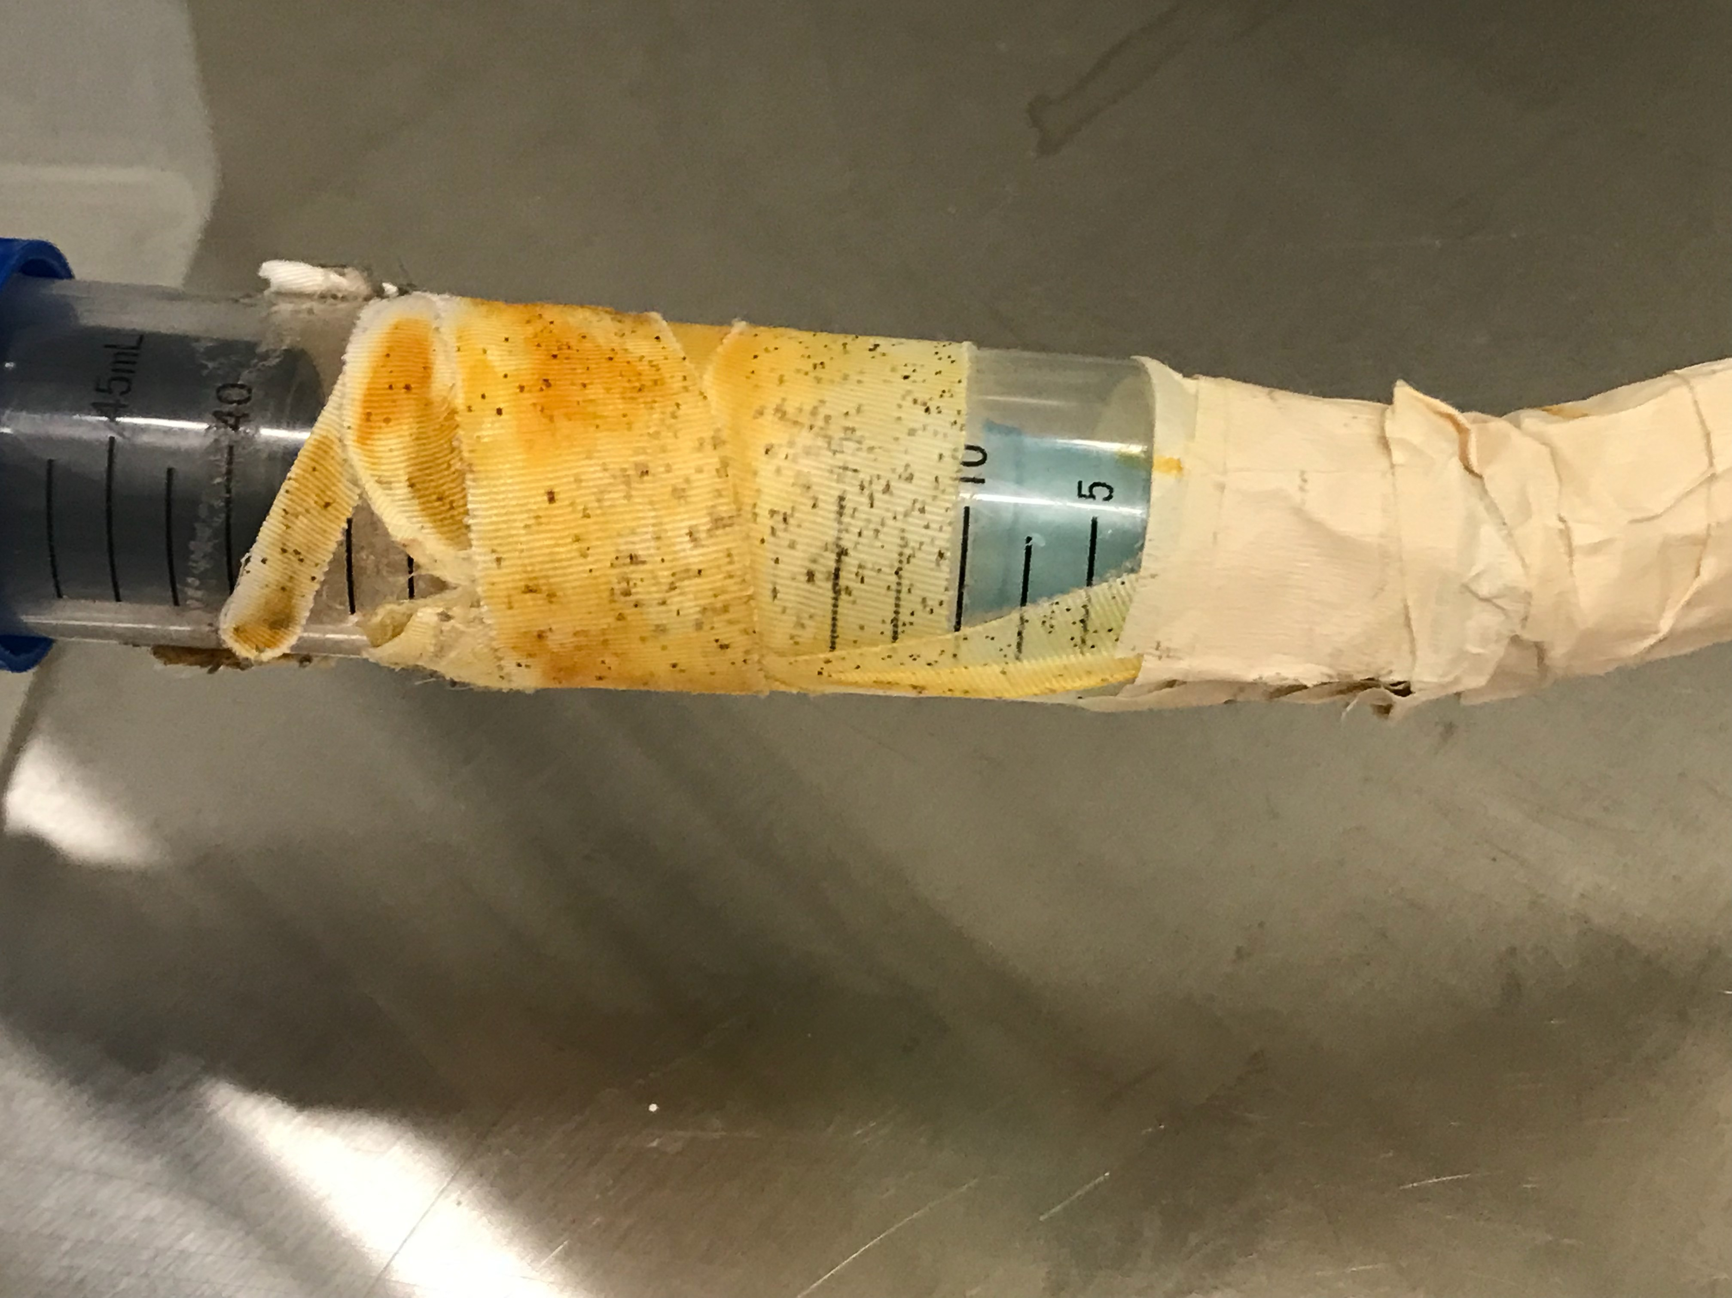  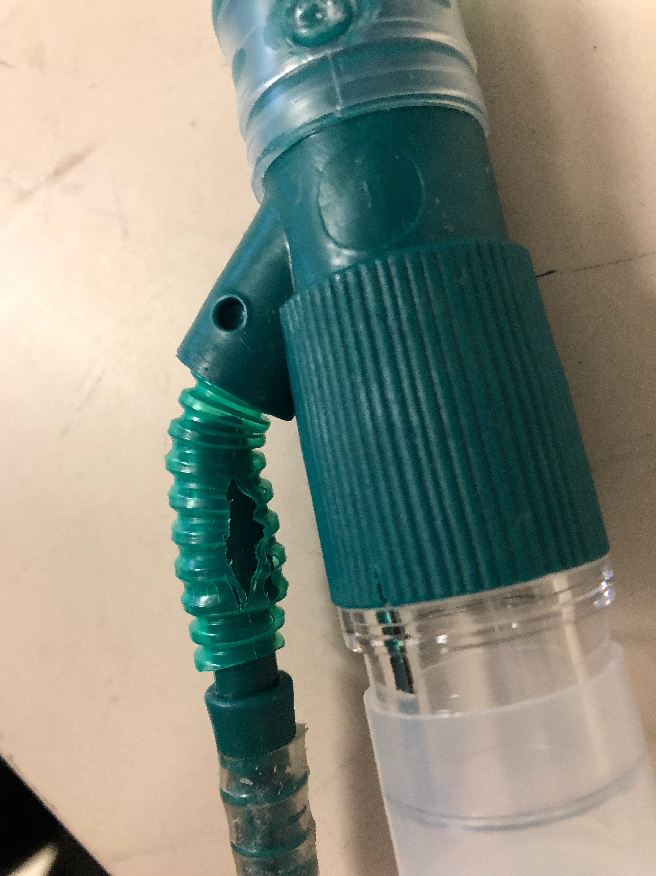 | 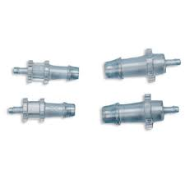  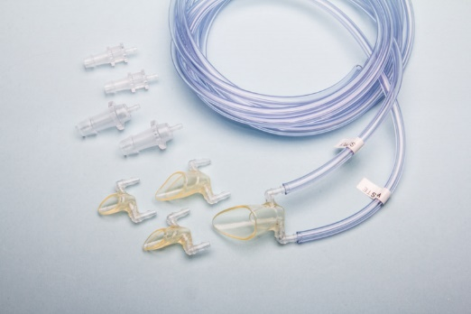  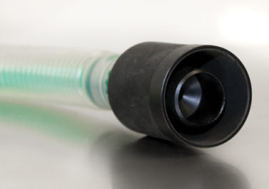

Topic | Undesirable Example | Proper Example
NOSE CONES  Use commercial nose cones.  Membrane required for non- angled nose cones.  Membrane must enclose both  nose and mouth.  Replace membrane when slit is too large or if cracking is observed. | 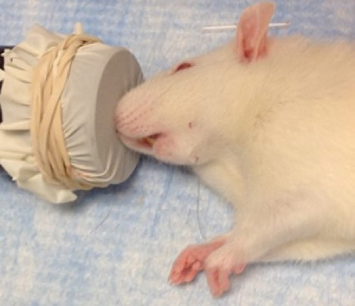  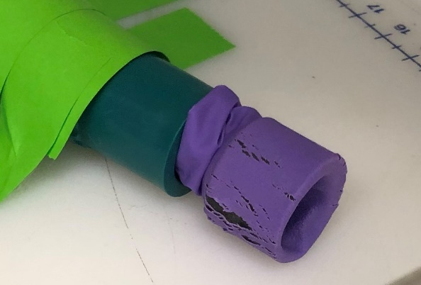 | 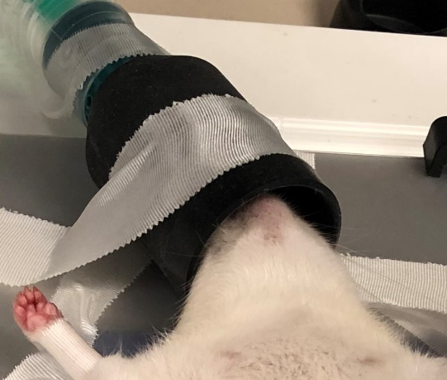  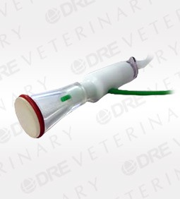  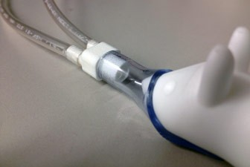
Topic | Undesirable Example | Proper Example
STEREOTAXIC FRAME-RODENT  Waste anesthetic gas must be scavenged. |  | 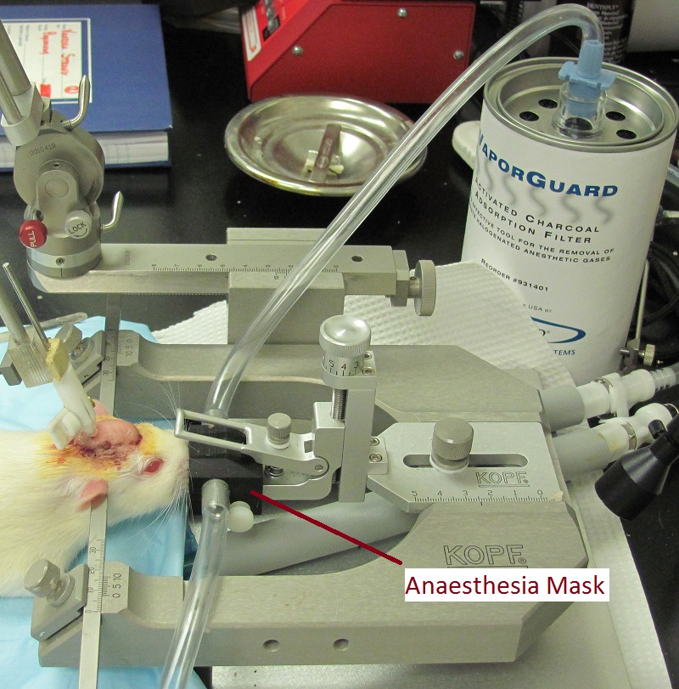

Topic | Undesirable Example |  | Proper Example
INDUCTION CHAMBERS  Household plasticware not permitted.  Induction chamber must vent into a ducted BSC, fume hood, or charcoal filter.  If not housed in a ducted BSC, or fume hood, flush chamber with air before opening. |  | 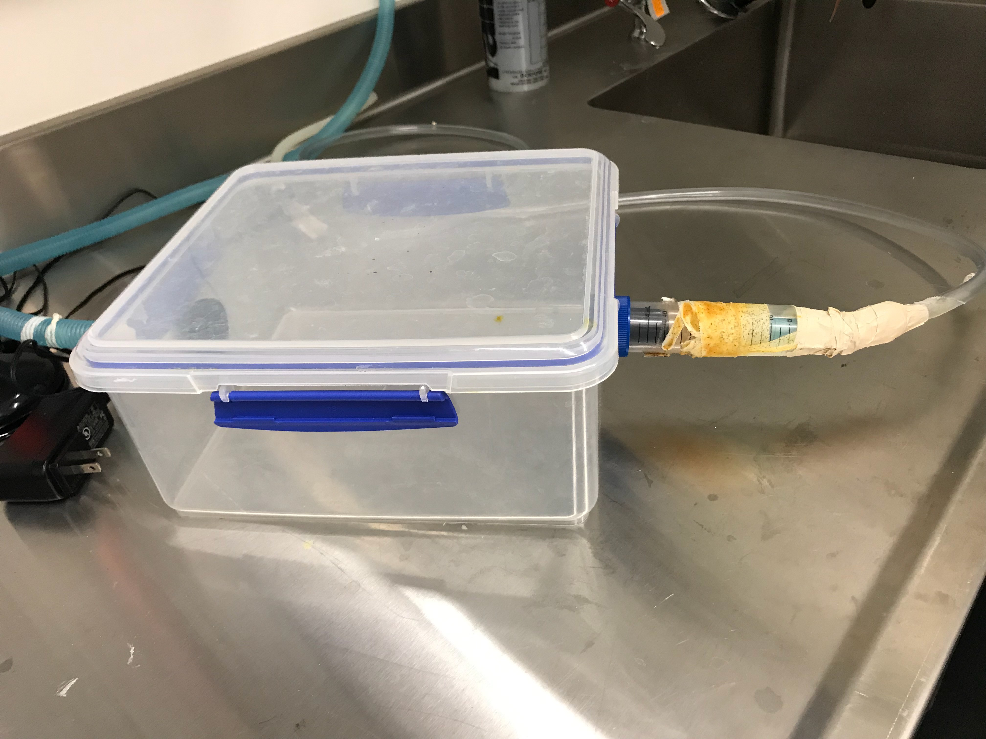 | 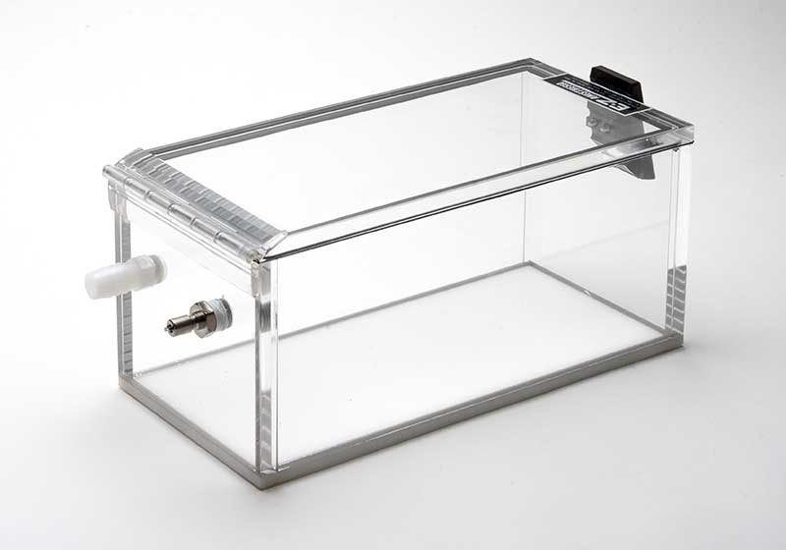
CHARCOAL CANISTER  Must be supported such that discharge openings are not occluded.  Canisters should be weighed after each use. Replace F/Air canister when it reaches 50g.  Follow manufacturer’s recommendations.  Dispose through chemical waste stream |  | 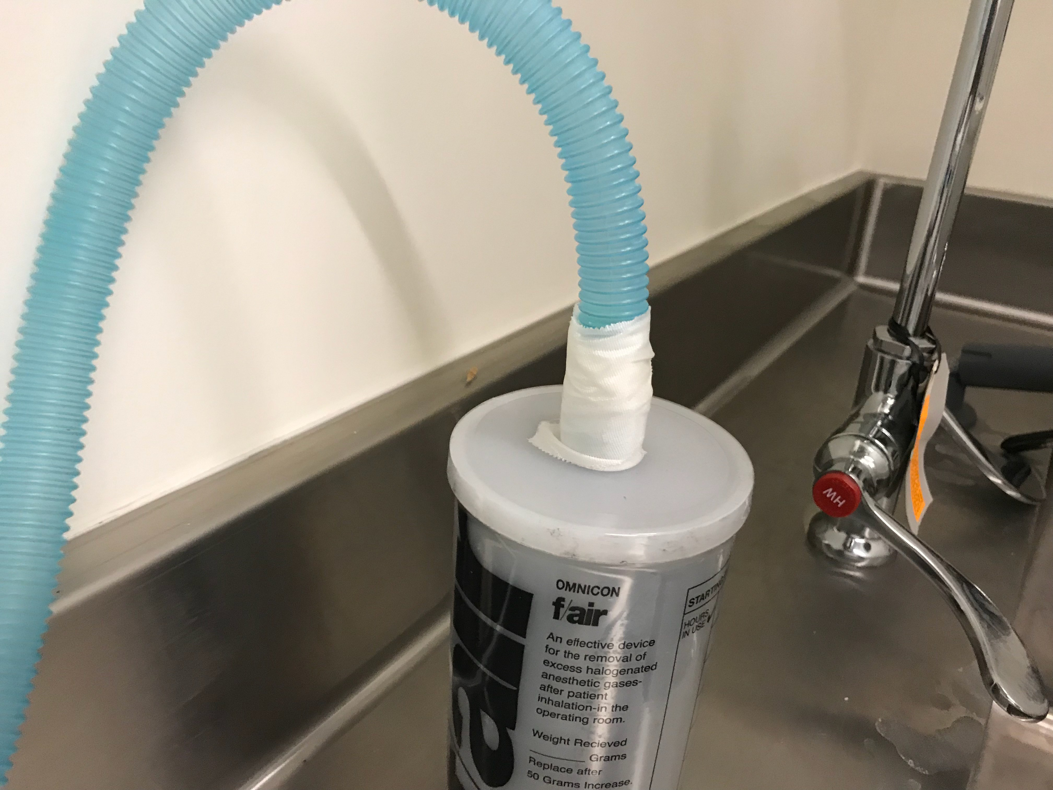 | 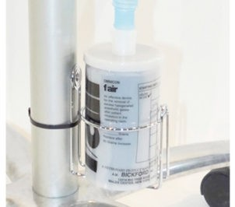  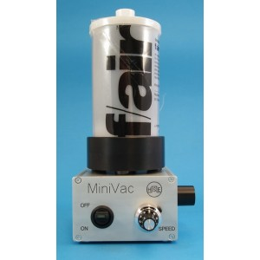
Topic |  | Undesirable Example | Proper Example
VAPORIZERS  Calibrate - (1-2 years)  Filled in fume hood or use a keyed refill tool.  Vaporizers must be secured by frame or equivalent.  Vaporizers are anesthetic specific |  |  | 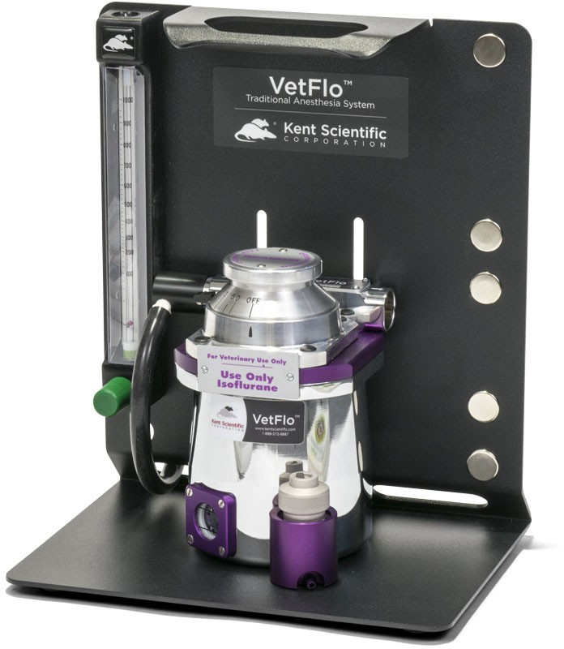
GENERAL CONDITIONS

Anesthesia may not be used in areas with recirculating ventilation systems or areas with less than 4 ACH

NOTES

