Why must I create a chemical inventory? 2
Must every chemical be tracked in the inventory or only “hazardous” ones? 2
Must we use the CisPro live system? 3
How do I register for a CisPro live chemical inventory account? 3
Can I upload a spreadsheet or inventory information from another system? 3
How much will this cost? 3
Must I use barcodes? 3
Am I required to share my inventory information with other lab groups? 4

Why must I create a chemical inventory?
Completion of chemical inventory is required for all Penn laboratories.

Accurate inventories of laboratory chemicals are needed in order to comply with granting agencies and regulatory requirements, including the Philadelphia Fire Code, which mandates the maximum allowable quantities for certain classes of chemicals.
An accurate inventory is also required to assist with emergency response procedures. Emergency personnel will not enter a space unless they are confident of the hazard information provided to them. Delayed response could lead to loss of research and increased damage to the laboratory and equipment.
Furthermore, accurate chemical inventory tracking reduces the amount of time and money your lab may otherwise waste on over-ordering, stockpiling, or disposing of expired chemicals.

Must every chemical be tracked in the inventory or only “hazardous” ones?
Penn requires your lab to track any hazardous research chemicals in your laboratory. This includes all solvents and other flammable liquids (including 200 proof ethanol), corrosives and hazardous gases (such as hydrogen, chlorine, ammonia, methane). All solid and liquid chemicals with hazard warnings on the bottle and/or Safety Data Sheet must be tracked in your inventory.

If a manufacturer has labeled a chemical container with one or more of these symbols, the chemical must be tracked in your inventory.
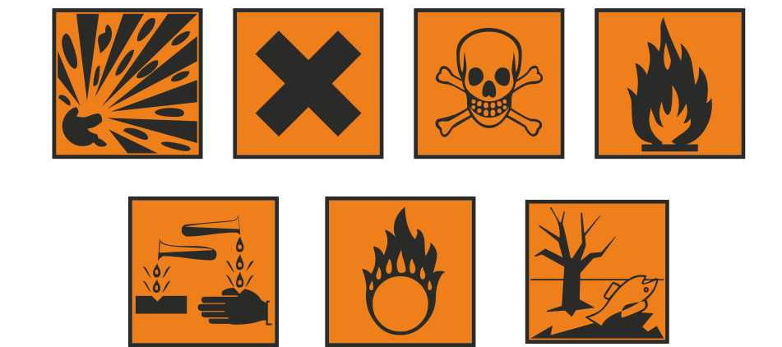
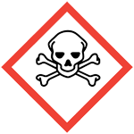

For information about what these pictograms mean, see the chemical’s SDS, or https://www.osha.gov/Publications/HazComm_QuickCard_Pictogram.html

Inventory amount is tracked by container size (i.e. “worst case scenario” quantities of chemical).

Consumer products such as Clorox bleach, glass cleaner, glass washing detergents, etc. are not required to be included in the chemical inventory. Non-hazardous materials such as cell-culture media, neutral-pH aqueous solutions, and agar are not required to be included in the chemical inventory either.

You are welcome to use your inventory to track any of these materials for your lab’s own information!

Must we use the CisPro live system?
Yes. Campus-wide tracking and reporting on chemical inventory is possible only if there is a unified system.

how do i register for a cispro live chemical inventory account?
The first step is to complete an account request form (link below). The request form can be found on the EHRS website.
http://www.ehrs.upenn.edu/programs/labsafety/cheminv/labinventoryaccount2.html
The Chemical Inventory Team will then contact you to schedule a one-on-one hands-on training session with an experienced inventory technician.

Can I upload a spreadsheet or inventory information from another system?
No. At this time, it is not possible to upload your spreadsheet into CISPro. All chemical containers must match a material record that is already in the system. If a chemical in your inventory is not found in the system, an EHRS Chemical Inventory Team member will create the record for you.

How much will this cost?
The CISPro Live system is available to all University of Pennsylvania research labs free of charge.

The only recommended equipment purchase is an inexpensive barcode wedge scanner. EHRS has pre-purchased barcode scanners that are available for purchase ($36 at the time of publishing). Any keyboard/wedge scanner will work with the system, special features are not required.
If you do not wish to purchase a barcode scanner, barcode numbers (6 to 10 digits) are printed on the barcode label and can be entered using your computer keyboard. You can always decide to purchase a scanner later, if desired.
Pre-printed barcode labels are provided by EHRS and are also free of charge.

Must I use barcodes?
Yes. The CISPro Live system recognizes each container—and its associated material, package, and size information—as a unique number code taken from the pre-printed label you assign to it. You may type this number instead of scanning the barcode label, but the number is how the container is identified and tracked.
If you are concerned about how the barcode labels may work with your containers (e.g. reagents that are stored in the refrigerator or are too small to accommodate the sticker) we can offer you some solutions. There is no requirement that the sticker be affixed to the container, only that container identity, location, owner, and disposal are accurately tracked. Ask EHRS if you have a situation that may require a creative solution to the use of barcode labels

Am I required to share my inventory information with other lab groups?
As a default, container information is kept hidden from other lab groups. You will only be able to view containers in your own inventory or in the inventory of labs for which you’ve been given permission (e.g. a shared lab facility). It is, however, possible to see the name of the lab that has a certain chemical.

