Why must I create a chemical inventory? 2
Must every chemical be tracked in the inventory or only “hazardous” ones? 2
Where can I get copy of the user manual I was given during my training? 3
Why can’t I log-in to CisPro Live? 3
How do I get more barcode labels 3
I can’t find a material record in cispro. What do I do? 3
How do I keep my inventory current and refresh my information regularly? 3
How are “Locations” barcodes used and how do I get them? 3

Why must I create a chemical inventory?
Completion of chemical inventory is required for all Penn laboratories.

Accurate inventories of laboratory chemicals are needed in order to comply with granting agencies and regulatory requirements, including the Philadelphia Fire Code, which mandates the maximum allowable quantities for certain classes of chemicals.
An accurate inventory is also required to assist with emergency response procedures. Emergency personnel will not enter a space unless they are confident of the hazard information provided to them. Delayed response could lead to loss of research and increased damage to the laboratory and equipment.
Furthermore, accurate chemical inventory tracking reduces the amount of time and money your lab may otherwise waste on over-ordering, stockpiling, or disposing of expired chemicals.

Must every chemical be tracked in the inventory or only “hazardous” ones?
Penn requires your lab to track any hazardous research chemicals in your laboratory. This includes all solvents and other flammable liquids (including 200 proof ethanol), corrosives and hazardous gases (such as hydrogen, chlorine, ammonia, methane). All solid and liquid chemicals with hazard warnings on the bottle and/or Safety Data Sheet must be tracked in your inventory.

If a manufacturer has labeled a chemical container with one or more of these symbols, the chemical must be tracked in your inventory.
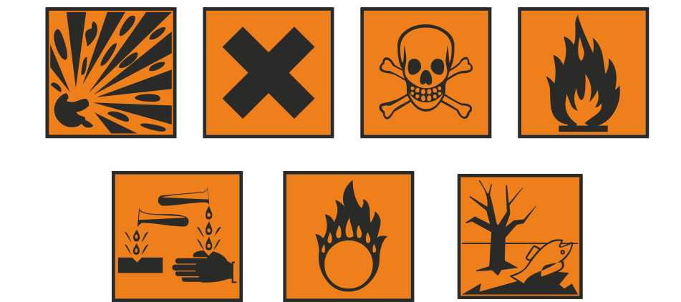
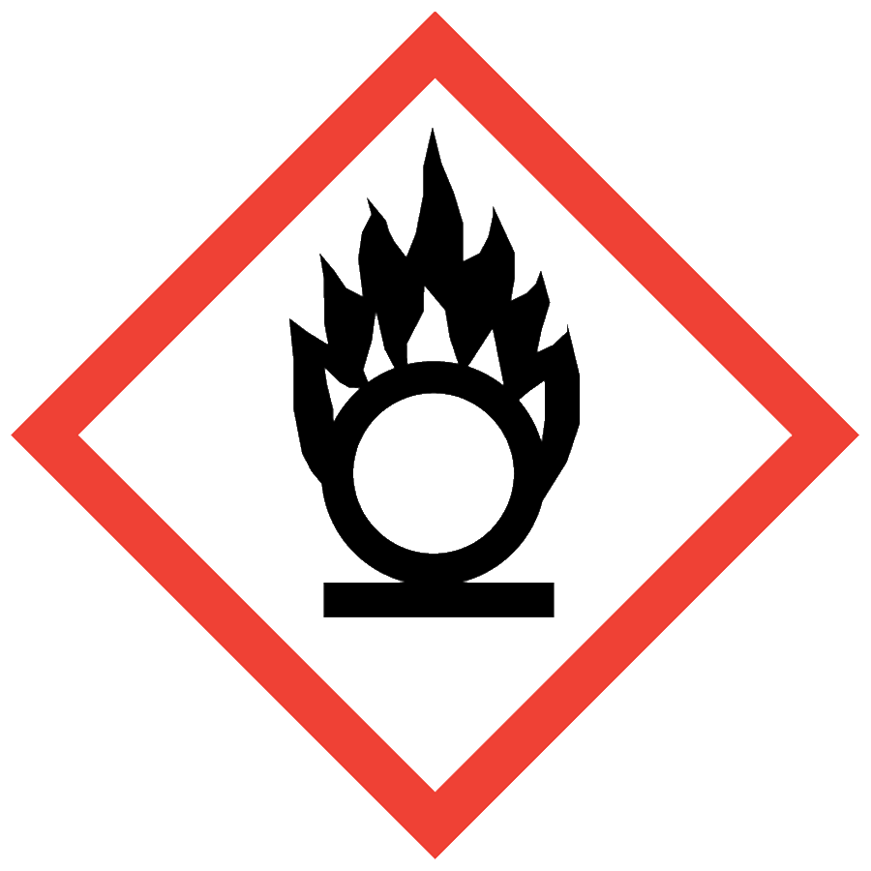
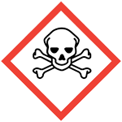

For information about what these pictograms mean, see the chemical’s SDS, or https://www.osha.gov/Publications/HazComm_QuickCard_Pictogram.html

Inventory amount is tracked by container size (i.e. “worst case scenario” quantities of chemical).

Consumer products such as Clorox bleach, glass cleaner, glass washing detergents, etc. are not required to be included in the chemical inventory. Non-hazardous materials such as cell-culture media, neutral-pH aqueous solutions, and agar are not required to be included in the chemical inventory either.

You are welcome to use your inventory to track any of these materials for your lab’s own information!

Where can I get copy of the user manual I was given during my training?
The user manual is posted in the Chemical Inventory Software section of the EHRS website.

Why can’t I log-in to CisPro Live?
Log-in issues may happen because:
- You are using the incorrect password. Passwords are a minimum of eight characters in length and must contain at least one numeric digit. EHRS cannot retrieve your password, but we can change it for you. Contact us for assistance if needed, cheminv@ehrs.upenn.edu.
- Too many users are logged-in to the system at the time you are trying to access it. Penn’s CISPro license only allows a certain number of simultaneous log-ins. If you receive an error telling you that too many people are logged-in, please report this to EHRS by emailing cheminv@ehrs.upenn.edu.
- Other fields are not correct on the log-in screen. Consult your CISPro user manual. The product name is “Biovia CISPro Live” and the customer name is “upenn”

How do I get more barcode labels?
Contact cheminv@ehrs.upenn.edu with your lab name and location. An EHRS Chemical Inventory Team Member will drop off a roll of 250 barcodes to your lab within 1 business day.

I can’t find a material record in cispro. What do I do?
Submit a “Problem-Container Form,” and EHRS will import or create the material and package for you. EHRS will email you to let you know when the record has been created. If you have more than 3 material records to create, use the Excel template file on the Problem-Container Form page.

How do I keep my inventory current and refresh my information regularly?
Your inventory is only as good as the work practices you use to keep it current. A good practice is to assign a limited number of people to take responsibility for receipt of new chemicals and for scanning-out empty containers. It is critical that labs with many inventory locations practice good management in returning containers to the correct location and record any intentional relocation of containers in CISPro. The EHRS Chemical Inventory Team is happy to work with labs to develop administrative protocols.
Contact EHRS at cheminv@ehrs.upenn.edu if you are interested in performing a reconciliation of your inventory. Our office owns a piece of equipment (Janam “smart scanner”) that allows us to re-scan every barcoded container into its current physical location. Missing containers and containers that have apparently moved from their last known location will be flagged and can be electronically “moved” into their new/real physical location.

A few weeks of advance notice is necessary to ensure that equipment and staffing is available to complete your reconciliation.

How are “Locations” barcodes used and how do I get them?
All unique locations in CISPro are given a code that is preceded by the letters “LS” (e.g. LS1235). EHRS can provide you with printed location barcodes upon request. If you would like to have new locations created in CISPro, contact cheminv@ehrs.upenn.edu.
Labs with many sub-locations within their rooms may find these helpful for moving containers from one location to another (See the user manual section “Moving chemicals one-by-one”). The keyboard/scanner function in the tools menu will allow you to scan the operation barcode “MOVE”. You then scan the container barcode followed by the barcode of the new location.
Location barcodes are also critical for inventory reconciliation using the Janam Smart Scanner (see “How do I keep my inventory current [. . . ]?” in this FAQ document). Contact EHRS at cheminv@ehrs.upenn.edu for a print-out of your location codes.

